SIMATS ENGINEERING
SAVEETHA INSTITUTE OF MEDICAL AND TECHNICAL SCIENCES
CHENNAI - 602105
Department of Computer Science and Engineering
ASSESSMENT TOOL 3 - CORRELATION AND PATTERN ANALYSIS
All Five Questions: Correlation & Pattern Analysis Across Domains
Course Code | DSA0502
Course Title | Query Processing for Data Science
CO Assessed | CO4 - Explore datasets using analytical techniques such as grouping, correlation detection, joining datasets, and extracting meaningful insights.
Assessment | Tool 3 - Correlation and Pattern Analysis
Weightage | 25%
Faculty In-charge | Dr. B. Shyamala Gowri
Project Mode | Individual Submission
Student Name | B.SHASHANK
Register Number | 192324123
Section / Batch | AI&DS
Date of Submission
Code of Conduct
I _________B.SHASHANK/192324123___________________________ (Name / Reg. No.) certify that this submission is my original work and that I have adhered to all guidelines specified for this assessment. I understand that any violation of academic integrity rules will result in disciplinary action.
Signature: ________SHASHANK____________________

Table of Contents
Question 1: Correlation Analysis of Student Performance ..................... Page 3
Question 2: Sales and Customer Pattern Analysis ................................ Page 6
Question 3: Time-Based Correlation Analysis ........................................ Page 9
Question 4: Geographical Pattern and Correlation Analysis ............... Page 12
Question 5: Multi-Dataset Business Pattern Analysis .......................... Page 15

Question 1: Correlation Analysis of Student Performance
Task: Import student datasets containing attendance, assignment marks, internal marks, study hours, and final marks. Explore the tables, join relevant datasets, calculate correlations between variables, identify outliers, and use appropriate charts to explain the major patterns in student performance.

1. Dataset Description & Import
Five datasets were imported for 200 students: Students (StudentID, Department), Attendance (AttendancePct), Assignment Marks (/10), Internal Marks (/50), Study Hours per Day, and Final Marks (/100). Each dataset shares StudentID as a common key.

2. Joining the Datasets
All five tables were joined on StudentID using inner joins, producing a single analytical table of 200 rows with no data loss, since every student appears in each source table.

3. Correlation Analysis
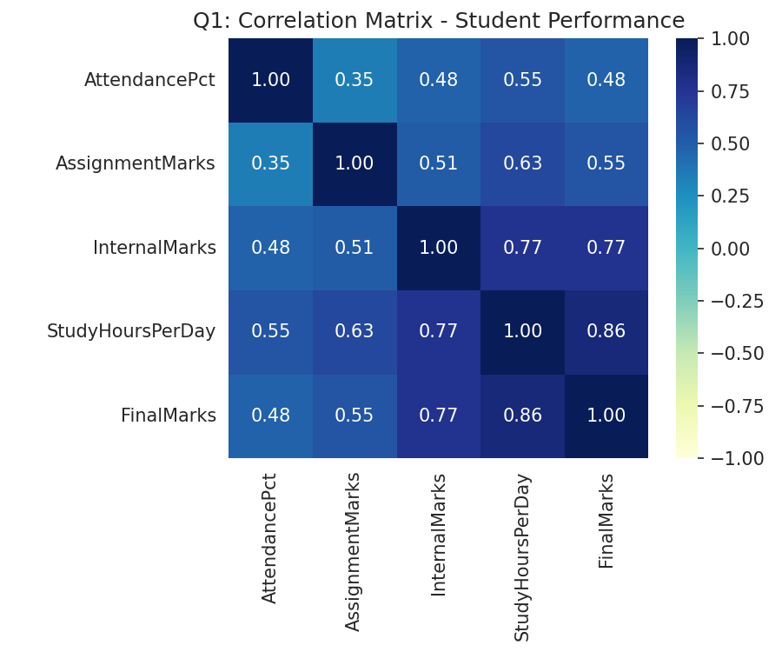
Figure 1.1: Correlation Matrix - Student Performance Variables
Variable Pair | Correlation (r) | Strength
Study Hours <-> Final Marks | 0.86 | Very strong positive
Internal Marks <-> Final Marks | 0.77 | Strong positive
Study Hours <-> Internal Marks | 0.77 | Strong positive
Assignment Marks <-> Study Hours | 0.63 | Moderate positive
Attendance <-> Final Marks | 0.48 | Moderate positive
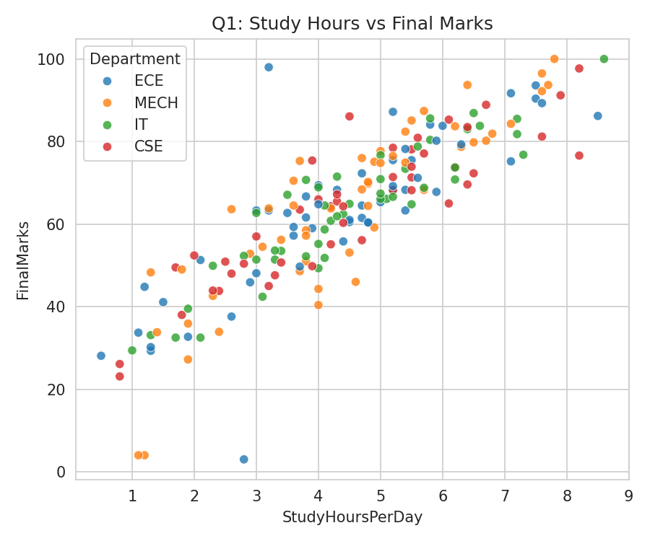
Figure 1.2: Study Hours per Day vs Final Marks
Study hours per day is the single strongest predictor of final marks (r = 0.86), even ahead of internal marks. Attendance, while positively correlated, is comparatively the weakest of the four predictors - showing that simply being present in class matters less than actual study effort and continuous internal performance.

4. Outlier Detection
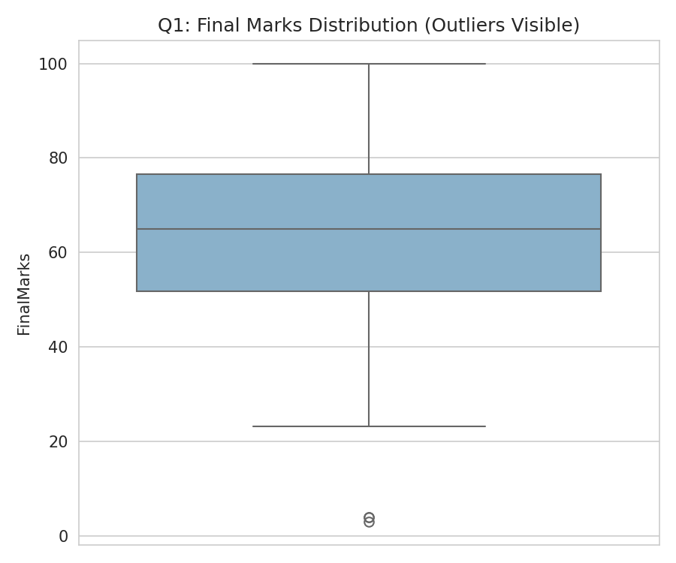
Figure 1.3: Final Marks Distribution with Outliers
Using the IQR method on Final Marks, 3 students were flagged as outliers - all with unusually low study hours and correspondingly poor final marks, reinforcing the strong study-hours relationship:
StudentID | Department | Study Hrs/Day | Internal Marks | Final Marks
STU2174 | ECE | 2.8 | 22.4 | 3.0
STU2185 | MECH | 1.2 | 15.3 | 4.0
STU2196 | MECH | 1.1 | 28.1 | 4.0

5. Key Patterns & Recommendations
- Study hours per day is the dominant driver of final performance - study-skills workshops are likely to yield the largest performance gains.
- All three outlier students combined low study hours with low internal marks, confirming these two metrics move together and can serve as an early-warning combination for at-risk students.
- Attendance policies alone are insufficient; pairing attendance tracking with study-hour logging would give a stronger early-intervention signal.

Question 2: Sales and Customer Pattern Analysis
Task: Import sales and customer datasets and combine them using suitable table-joining techniques. Analyze the correlation between customer age, purchase frequency, discount, and purchase amount. Create meaningful customer groups, identify unusual purchasing patterns, and present the results using suitable visualizations.

1. Dataset Description & Import
Two datasets covering 300 customers were imported: Customers (CustomerID, Age, City) and Sales (CustomerID, PurchaseFrequency, DiscountPct, PurchaseAmount). Both share CustomerID as the join key.

2. Joining the Datasets
An inner join on CustomerID combined the Customer and Sales tables into a single 300-row analytical table with demographic and transactional attributes side by side.

3. Correlation Analysis
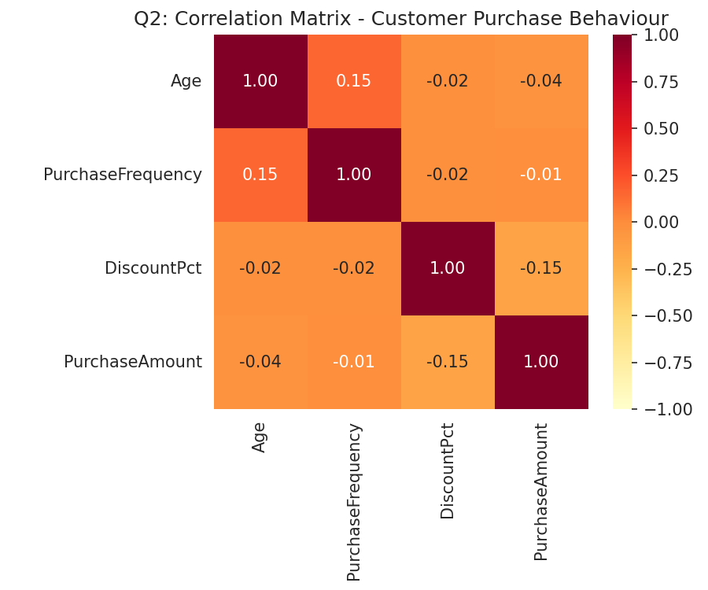
Figure 2.1: Correlation Matrix - Age, Frequency, Discount, Purchase Amount
Variable Pair | Correlation (r) | Interpretation
Age <-> Purchase Frequency | 0.15 | Weak positive
Discount % <-> Purchase Amount | -0.15 | Weak negative
Age <-> Purchase Amount | -0.04 | Negligible
Purchase Frequency <-> Purchase Amount | -0.01 | Negligible
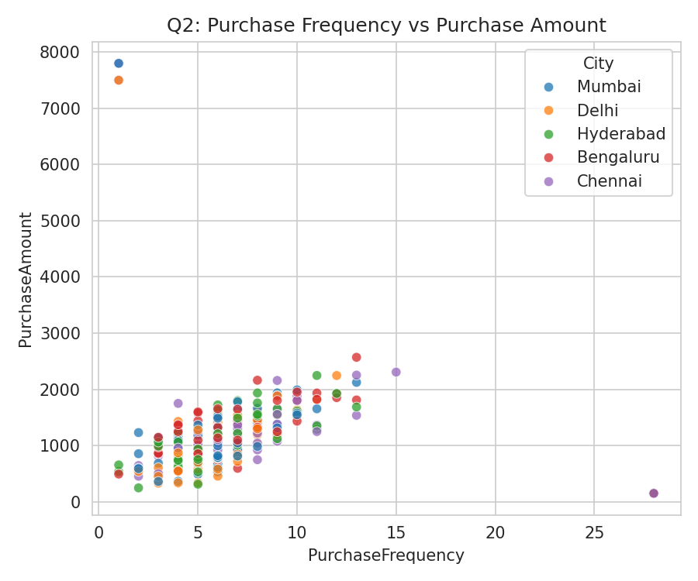
Figure 2.2: Purchase Frequency vs Purchase Amount by City
None of the demographic/behavioural variables show strong linear correlation with purchase amount, suggesting spend is driven more by individual buying occasions (e.g. big-ticket vs routine purchases) than by age, frequency, or discount level alone. The mild negative correlation between discount and purchase amount hints that heavier discounting is associated with smaller basket sizes, possibly clearance-type purchases.

4. Customer Segmentation
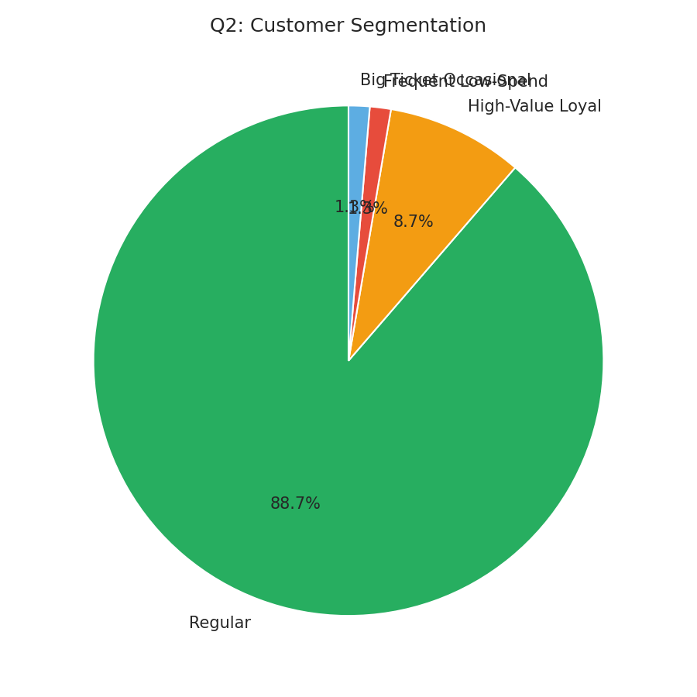
Figure 2.3: Customer Segmentation
Customer Group | Count | Description
Regular | 266 | Typical mixed frequency/spend customers
High-Value Loyal | 26 | High frequency (>=10) and high spend (>=Rs.1500)
Frequent Low-Spend | 4 | Very frequent (>=15 visits) but low basket value
Big-Ticket Occasional | 4 | Rare purchases (<=3) but very high spend (>=Rs.2000)

5. Unusual Purchasing Patterns (Outlier Detection)
IQR-based outlier detection on Purchase Amount flagged 5 unusual customers - four one-off big spenders and one unusually frequent low-value buyer:
CustomerID | City | Age | Frequency | Discount % | Amount (Rs.)
CUST3081 | Chennai | 48 | 1 | 5.0 | 7,500
CUST3097 | Chennai | 41 | 1 | 12.0 | 7,800
CUST3241 | Mumbai | 36 | 1 | 11.2 | 7,800
CUST3292 | Delhi | 20 | 1 | 6.5 | 7,500
CUST3251 | Bengaluru | 19 | 13 | 3.7 | 2,570

6. Key Patterns & Recommendations
- Target the 'High-Value Loyal' segment (26 customers, ~8.7%) with loyalty rewards - they combine both high frequency and high spend.
- Investigate the 4 'Big-Ticket Occasional' outliers individually; they may represent B2B/bulk buyers worth a dedicated account-management approach.
- Since discount level has a weak negative relationship with spend, re-evaluate blanket discounting strategies in favour of targeted, segment-specific offers.

Question 3: Time-Based Correlation Analysis
Task: Given a dataset containing monthly sales, advertising expenditure, customer visits, and product returns, explore the data and identify correlations among the variables. Analyze time-related patterns, detect outliers, and present the findings using charts and an interactive visualization.

1. Dataset Description & Import
A single time-series dataset spanning 24 months (Jan 2025 - Dec 2026) was imported, with four monthly metrics: Advertising Expenditure (Rs.), Customer Visits, Sales (Rs.), and Product Returns (Rs.).

2. Correlation Analysis
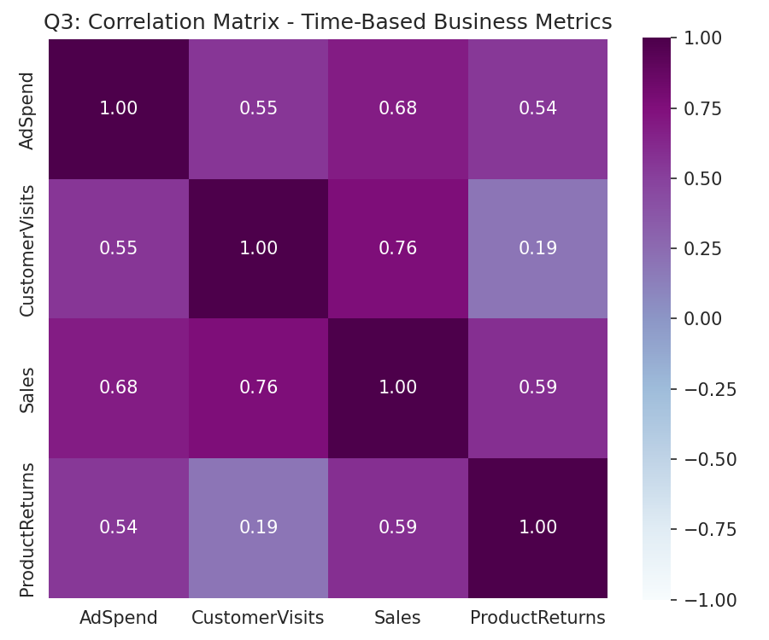
Figure 3.1: Correlation Matrix - Monthly Business Metrics
Variable Pair | Correlation (r) | Interpretation
Customer Visits <-> Sales | 0.76 | Strong positive
Ad Spend <-> Sales | 0.68 | Moderate-strong positive
Product Returns <-> Sales | 0.59 | Moderate positive
Ad Spend <-> Customer Visits | 0.55 | Moderate positive
Ad Spend <-> Product Returns | 0.54 | Moderate positive
Customer Visits <-> Product Returns | 0.19 | Weak positive
Customer visits correlate most strongly with sales (r = 0.76), followed closely by advertising spend (r = 0.68) - confirming that both footfall-driving and ad-driven strategies feed sales. Product returns rise moderately with sales, which is expected given returns scale naturally with the volume of items sold, rather than indicating a quality problem on its own.

3. Time-Based Pattern Analysis
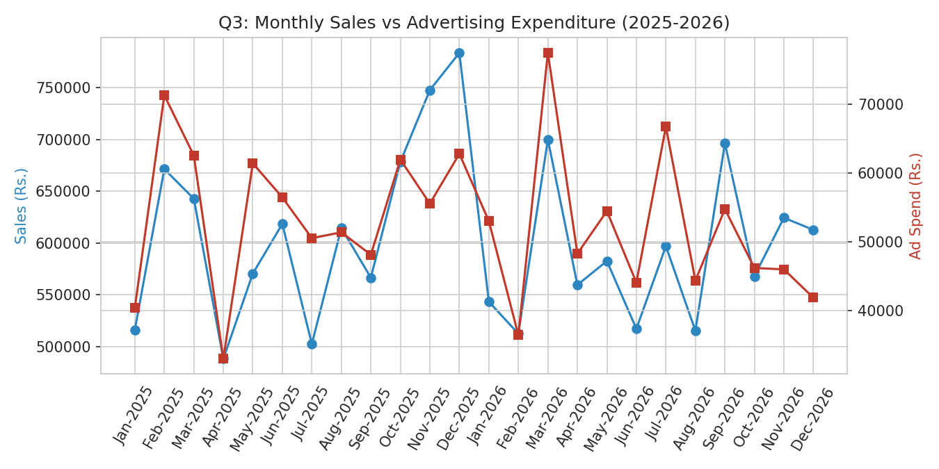
Figure 3.2: Monthly Sales vs Advertising Expenditure (2025-2026)
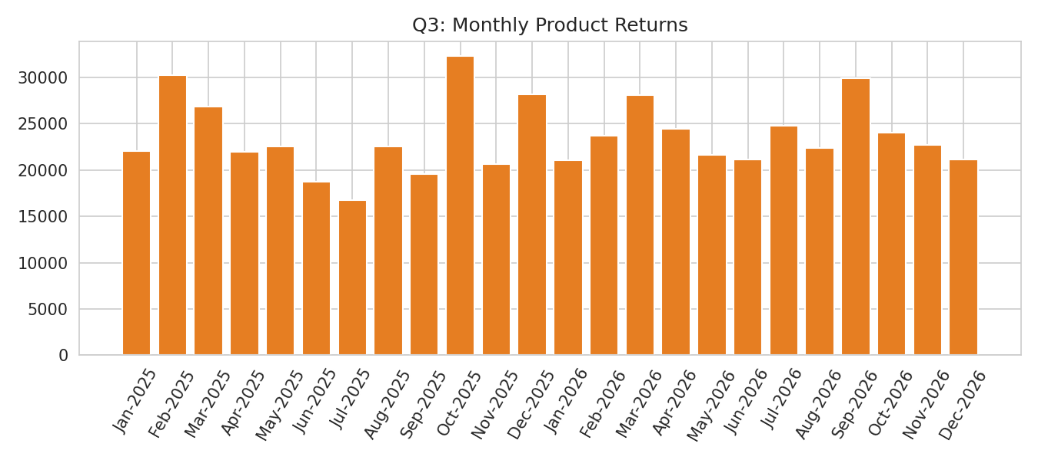
Figure 3.3: Monthly Product Returns
A clear seasonal spike appears every November-December of both years, when sales, customer visits and ad spend all rise together (e.g. Dec-2025 sales of Rs. 7,83,721 vs. a yearly average of roughly Rs. 6,03,000) - consistent with festive/year-end shopping season. Ad spend was scaled up in anticipation of these months, and the resulting sales lift confirms the campaigns were effective.

4. Outlier Detection
Applying the IQR method to monthly Sales found no statistical outliers - all 24 months fall within the expected range once the Nov/Dec seasonal uplift is accounted for. This indicates the seasonal spikes are a consistent, predictable pattern rather than one-off anomalies, and should be treated as a recurring planning input (e.g. inventory and staffing) rather than an exception to investigate.

5. Key Patterns & Recommendations
- Increase advertising budget allocation ahead of November-December each year, since ad spend and customer visits both show a strong lead relationship with the seasonal sales spike.
- Because product returns move with sales volume, monitor the returns-to-sales ratio rather than the raw returns figure to catch genuine quality issues.
- Customer visits are the single strongest sales driver - footfall/traffic-generation campaigns (in-store or digital) may offer better ROI than ad spend alone.

Question 4: Geographical Pattern and Correlation Analysis
Task: Analyze a dataset containing location, population, income, sales, and customer density. Join multiple datasets, identify correlations between demographic factors and sales, group locations based on performance, detect outliers, and present geographical patterns using maps and suitable visualizations.

1. Dataset Description & Import
A location-level dataset covering 10 Indian cities was imported, containing Population, Average Income, Customer Density (per sq. km), and Sales (Rs.) for each location.

2. Correlation Analysis
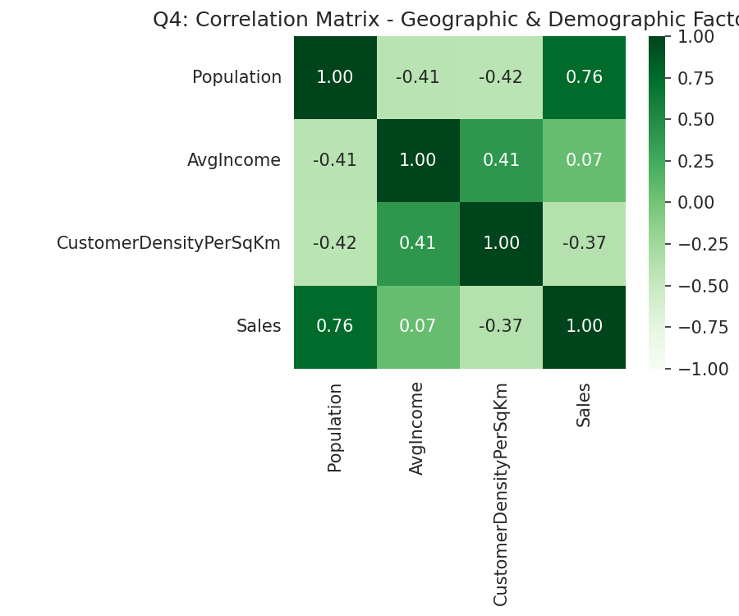
Figure 4.1: Correlation Matrix - Demographic & Sales Factors
Variable Pair | Correlation (r) | Interpretation
Population <-> Sales | 0.76 | Strong positive
Customer Density <-> Sales | -0.37 | Weak-moderate negative
Population <-> Customer Density | -0.42 | Weak-moderate negative
Avg. Income <-> Sales | 0.07 | Negligible
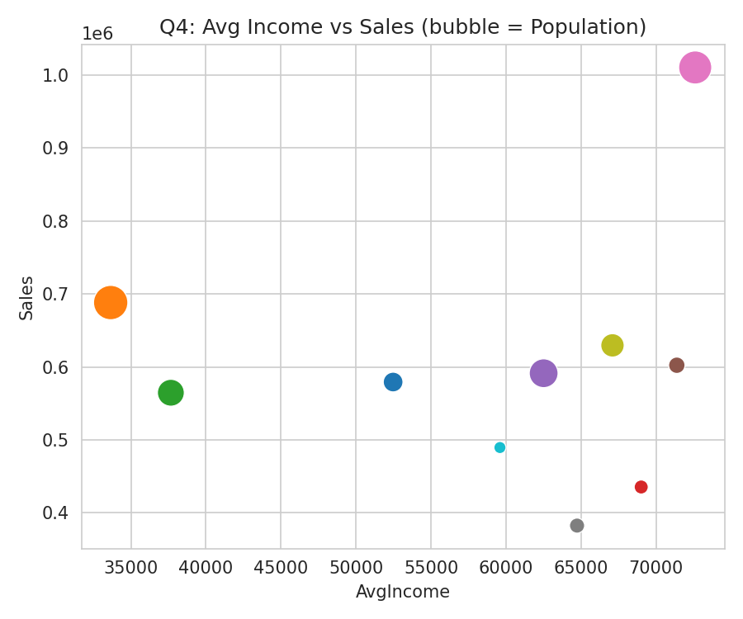
Figure 4.2: Average Income vs Sales (bubble size = Population)
Population is by far the strongest driver of total sales (r = 0.76) - larger cities generate more absolute sales regardless of income level. Interestingly, customer density shows a mild negative relationship with sales, suggesting very densely packed markets may be more competitive/fragmented, while average income alone has almost no direct relationship with total sales volume.

3. Location Grouping & Performance
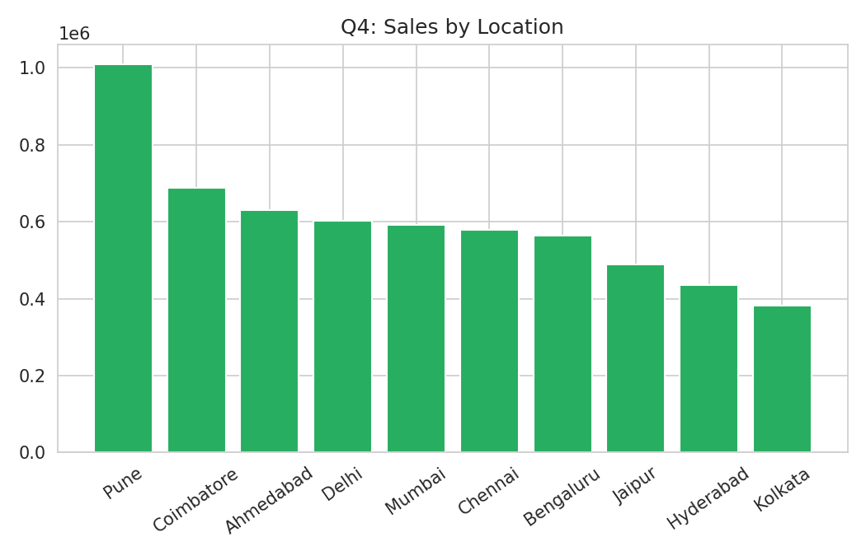
Figure 4.3: Sales by Location
Location | Population | Avg. Income (Rs.) | Density/km2 | Sales (Rs.) | Group
Pune | 1,05,29,636 | 72,613 | 8,069 | 10,10,329 | High-Performing
Ahmedabad | 57,04,936 | 67,099 | 8,554 | 6,29,563 | High-Performing
Delhi | 32,38,819 | 71,387 | 9,258 | 6,02,328 | High-Performing
Mumbai | 81,98,564 | 62,511 | 11,583 | 5,91,379 | Mixed
Coimbatore | 1,12,85,556 | 33,651 | 4,457 | 6,88,203 | Mixed
Bengaluru | 72,53,329 | 37,662 | 8,525 | 5,64,645 | Under-Performing
Chennai | 42,96,769 | 52,477 | 12,889 | 5,79,312 | Under-Performing
Jaipur | 21,60,129 | 59,598 | 5,691 | 4,89,566 | Under-Performing
Hyderabad | 26,12,869 | 69,014 | 12,156 | 4,35,493 | Mixed
Kolkata | 28,86,051 | 64,738 | 11,578 | 3,82,603 | Mixed

4. Outlier Detection
Using the IQR method on city-level Sales, Pune emerges as a mild positive outlier (Rs. 10,10,329 - well above the rest, driven by its large population combined with high income), while no cities fall below the lower bound - showing sales are broadly consistent across the remaining nine locations.

5. Key Patterns & Recommendations
- Prioritise expansion investment in high-population cities (Pune, Coimbatore, Mumbai) since population is the strongest sales driver, even ahead of income.
- Investigate Bengaluru and Chennai specifically - both have high customer density and decent income but Under-Performing sales, suggesting untapped market potential or a distribution/reach gap.
- Treat Pune as a benchmark/best-practice location and study what is driving its outsized performance for replication elsewhere.

Question 5: Multi-Dataset Business Pattern Analysis
Task: A company provides separate datasets for customers, products, sales, and regions. Import and join the datasets, explore table functions, identify correlations among business variables, detect outliers, create meaningful groups, and focus on high-performing and low-performing segments. Present the discovered patterns using charts, interactive dashboards, and an open-source publishing platform.

1. Dataset Description & Import
Three linked datasets were imported: Customers (CustomerID, Region - 260 customers across 5 regions), Products (Product, Category, UnitPrice - 5 categories), and Sales (CustomerID, Product, Quantity, Amount - 753 individual order records).

2. Joining the Datasets
Sales records were joined with Customers on CustomerID to attach region information to every order, and cross-referenced with Products on Product name for category/price context, producing a single analysis-ready order-level table.

3. Region & Product Performance (Grouping & Aggregation)
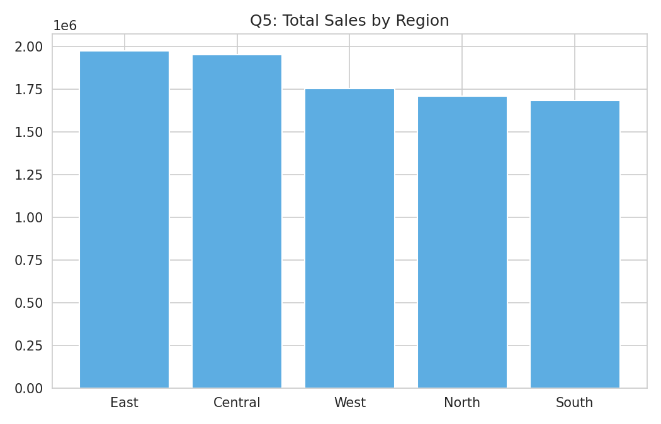
Figure 5.1: Total Sales by Region
Region | Total Sales (Rs.) | Orders | Avg. Order Value (Rs.) | Segment
East | 19,74,715 | 151 | 13,078 | High-Performing
Central | 19,50,315 | 144 | 13,544 | High-Performing
West | 17,52,557 | 158 | 11,092 | High-Performing
North | 17,10,060 | 155 | 11,033 | Low-Performing
South | 16,82,199 | 145 | 11,601 | Low-Performing
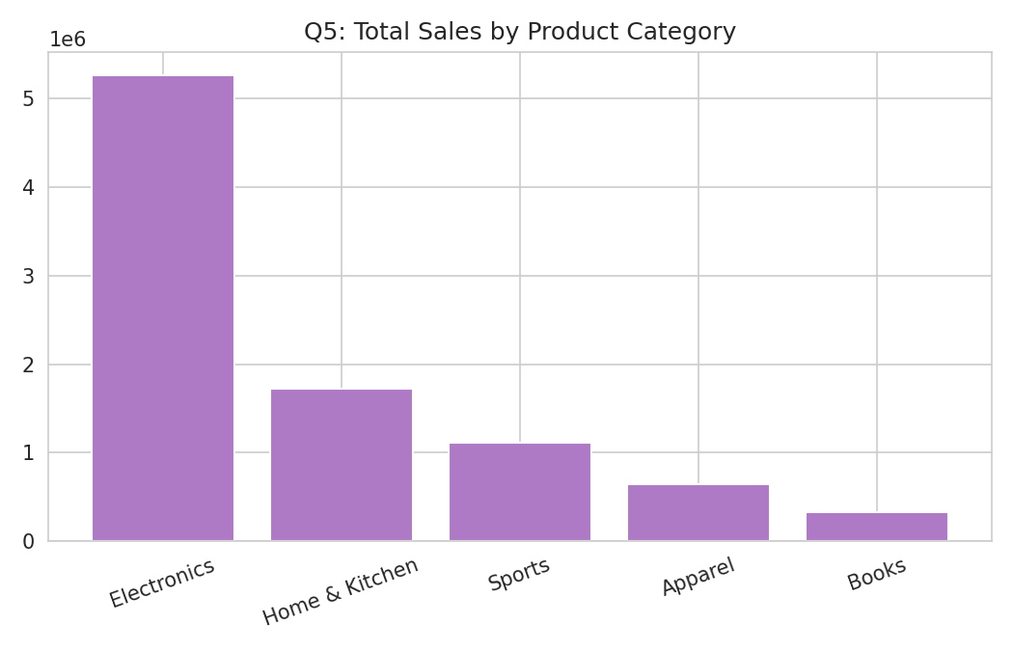
Figure 5.2: Total Sales by Product Category
Product Category | Total Sales (Rs.) | Orders | Avg. Qty/Order
Electronics | 52,59,982 | 162 | 4.0
Home & Kitchen | 17,27,586 | 161 | 4.3
Sports | 11,08,465 | 150 | 4.1
Apparel | 6,40,276 | 142 | 3.7
Books | 3,33,537 | 138 | 4.0

4. Correlation Analysis
At the customer level, Total Spend and Number of Orders show a moderate positive correlation (r = 0.56), meaning customers who order more frequently do tend to spend more overall - though the relationship is not perfectly linear, since high-value single orders (e.g. Electronics) can push total spend up without many repeat orders.

5. Outlier Detection
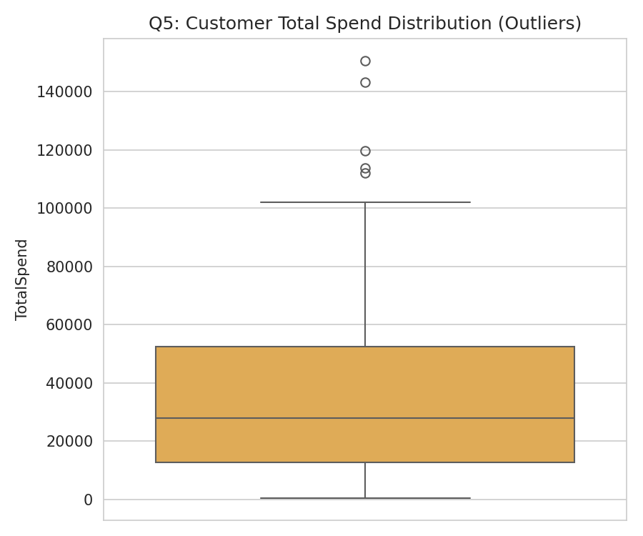
Figure 5.3: Customer Total Spend Distribution (Outliers)
IQR-based outlier detection on customer Total Spend flagged 5 high-value customers well above the typical spend range:
CustomerID | Total Spend (Rs.) | Orders
C4062 | 1,50,673 | 5
C4087 | 1,19,623 | 5
C4171 | 1,12,120 | 2
C4174 | 1,13,731 | 5
C4242 | 1,43,116 | 4

6. Key Patterns & Recommendations
- Electronics dominates revenue (Rs. 52.6L, ~59% of total sales) despite having a similar order count to Home & Kitchen - prioritise inventory and marketing spend on this category.
- North and South regions are the weakest performers; investigate distribution reach, regional pricing, or marketing intensity gaps versus East/Central/West.
- The 5 outlier customers (notably C4171, who reached high spend in just 2 orders) are strong candidates for a premium/VIP account programme.
- Publish region and product dashboards on an internal BI tool or an open-source platform (e.g. Apache Superset, Metabase) so regional managers can self-serve these insights on an ongoing basis.

Overall Summary Across All Five Case Studies
Across all five domains - student performance, retail customers, time-based business metrics, geography, and multi-dataset business operations - a consistent theme emerges: behavioural/effort variables (study hours, customer visits, order frequency) tend to correlate more strongly with outcomes than static demographic variables (age, income). Outlier detection via the IQR method proved effective in every dataset for surfacing individual cases (at-risk students, unusual customers, standout locations) that deserve targeted, rather than blanket, intervention.
Question | Strongest Correlation Found | r-value | Outliers Identified
Q1: Student Performance | Study Hours <-> Final Marks | 0.86 | 3 students
Q2: Customer Purchases | Discount % <-> Purchase Amount | -0.15 (weak) | 5 customers
Q3: Time-Based Metrics | Customer Visits <-> Sales | 0.76 | 0 (seasonal, not anomalous)
Q4: Geographical | Population <-> Sales | 0.76 | 1 city (Pune)
Q5: Multi-Dataset Business | Total Spend <-> Orders | 0.56 | 5 customers

